**Hub** –  A hub is basically a multiport repeater. A hub connects multiple wires coming from different branches, for example, the connector in star topology which connects different stations. Hubs cannot filter data, so data packets are sent to all connected devices.  In other words, the [collision domain](https://en.wikipedia.org/wiki/Collision_domain) of all hosts connected through Hub remains one.  Also, they do not have the intelligence to find out the best path for data packets which leads to inefficiencies and wastage.

**Types of Hub**

**Active Hub:-** These are the hubs that have their own power supply and can clean, boost, and relay the signal along with the network. It serves both as a repeater as well as a wiring center. These are used to extend the maximum distance between nodes.

**Passive Hub :-** These are the hubs that collect wiring from nodes and power supply from the active hub. These hubs relay signals onto the network without cleaning and boosting them and can’t be used to extend the distance between nodes.

**Intelligent Hub :-**It works like active hubs and includes remote management capabilities. They also provide flexible data rates to network devices. It also enables an administrator to monitor the traffic passing through the hub and to configure each port in the hub.

[**Routers**](https://www.geeksforgeeks.org/network-devices-hub-repeater-bridge-switch-router-gateways/#Routers)**–** A router is a device like a switch that routes data packets based on their IP addresses. The router is mainly a Network Layer device. Routers normally connect LANs and WANs together and have a dynamically updating routing table based on which they make decisions on routing the data packets. Router divide broadcast domains of hosts connected through it.

**Switch –** A switch is a multiport bridge with a buffer and a design that can boost its efficiency(a large number of ports imply less traffic) and performance. A switch is a data link layer device. The switch can perform error checking before forwarding data, which makes it very efficient as it does not forward packets that have errors and forward good packets selectively to the correct port only.  In other words, the switch divides the collision domain of hosts, but [broadcast domain](https://en.wikipedia.org/wiki/Broadcast_domain) remains the same.

**Repeater –** A repeater operates at the physical layer. Its job is to regenerate the signal over the same network before the signal becomes too weak or corrupted so as to extend the length to which the signal can be transmitted over the same network. An important point to be noted about repeaters is that they do not amplify the signal. When the signal becomes weak, they copy the signal bit by bit and regenerate it at the original strength. It is a 2 port device.

**Modem**

Modem is a device that enables a computer to send or receive data over telephone or cable lines. The data stored on the computer is digital whereas a telephone line or cable wire can transmit only analog data.

The main function of the modem is to convert digital signal into analog and vice versa. Modem is a combination of two devices − modulator and demodulator. The modulator converts digital data into analog data when the data is being sent by the computer. The demodulator converts analog data signals into digital data when it is being received by the computer.

**Types of cables**

* Unshielded Twisted Pair (UTP) Cable
* Shielded Twisted Pair (STP) Cable
* Coaxial Cable
* Fiber Optic Cable
* Wireless LANs

**Gateway**

A **gateway** is a piece of [networking hardware](https://en.wikipedia.org/wiki/Networking_hardware) or software used in [telecommunications](https://en.wikipedia.org/wiki/Telecommunication) for telecommunications networks that allows data to flow from one discrete network to another. Gateways are distinct from [routers](https://en.wikipedia.org/wiki/Router_(computing)) or [switches](https://en.wikipedia.org/wiki/Network_switch) in that they communicate using more than one protocol to connect multiple networks

**Ping:**

The [ping](https://www.lifewire.com/how-to-ping-computer-or-website-818405) command is a [Command Prompt command](https://www.lifewire.com/list-of-command-prompt-commands-4092302) used to test the ability of the source computer to reach a specified destination computer. It's usually used as a simple way to verify that a computer can communicate over the network with another computer or network device.

The ping command operates by sending Internet Control Message Protocol (ICMP) Echo Request messages to the destination computer and waiting for a response. How many of those responses are returned, and how long it takes for them to return, are the two major pieces of information that the ping command provides

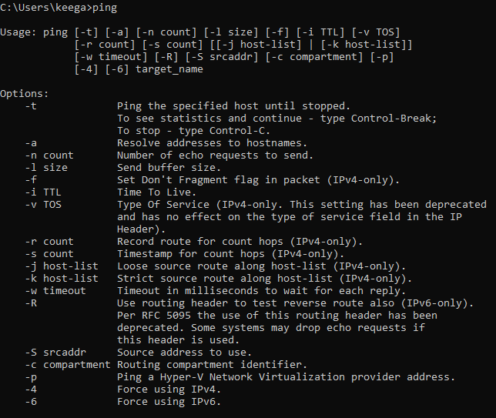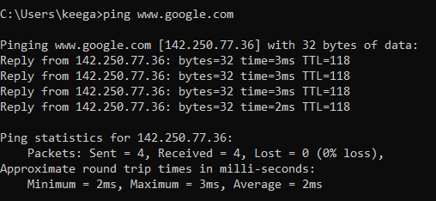

**Tracert:**

The tracert command (spelled traceroute in Unix/Linux implementations) is one of the key diagnostic tools for TCP/IP. It displays a list of all the routers that a packet must go through to get from the computer where tracert is run to any other computer on the Internet. Each one of these routers is called a hop

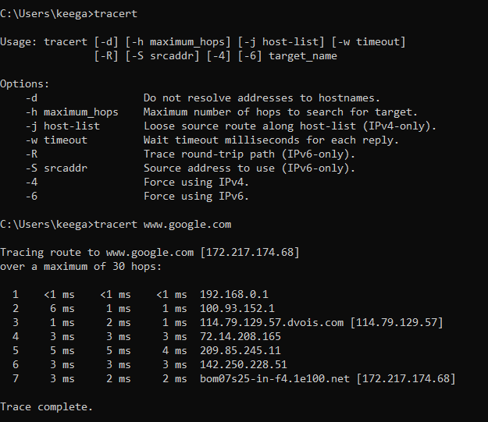

**Getmac:**

We can find mac address (physical address) of a computer using the command ‘*getmac*‘. This can be used to get mac address for remote computers also.

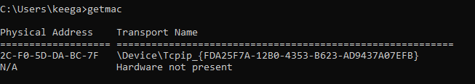

**Ipconfig:**

ipconfig (standing for "Internet Protocol configuration") is a console application program of some computer operating systems that displays all current TCP/IP network configuration values

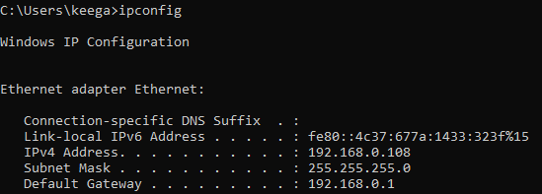

**Nslookup:**

nslookup (from name server lookup) is a network administration command-line tool for querying the Domain Name System (DNS) to obtain the mapping between domain name and IP address, or other DNS records.

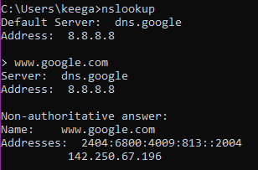

**Netstat:**

The netstat command generates displays that show network status and protocol statistics. You can display the status of TCP and UDP endpoints in table format, routing table information, and interface information.

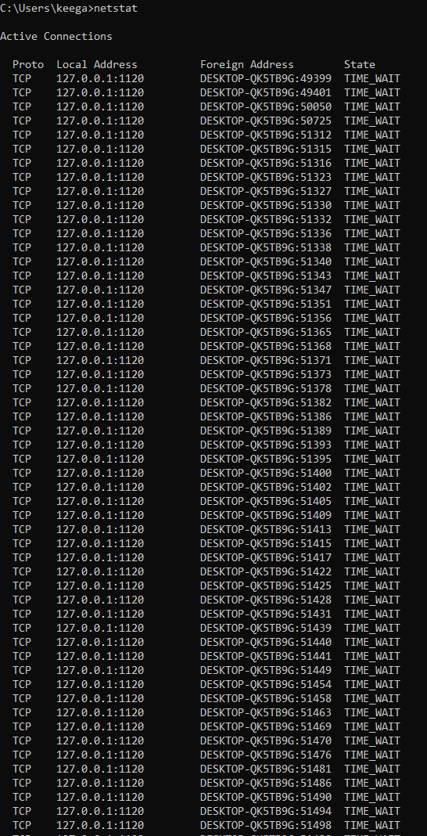

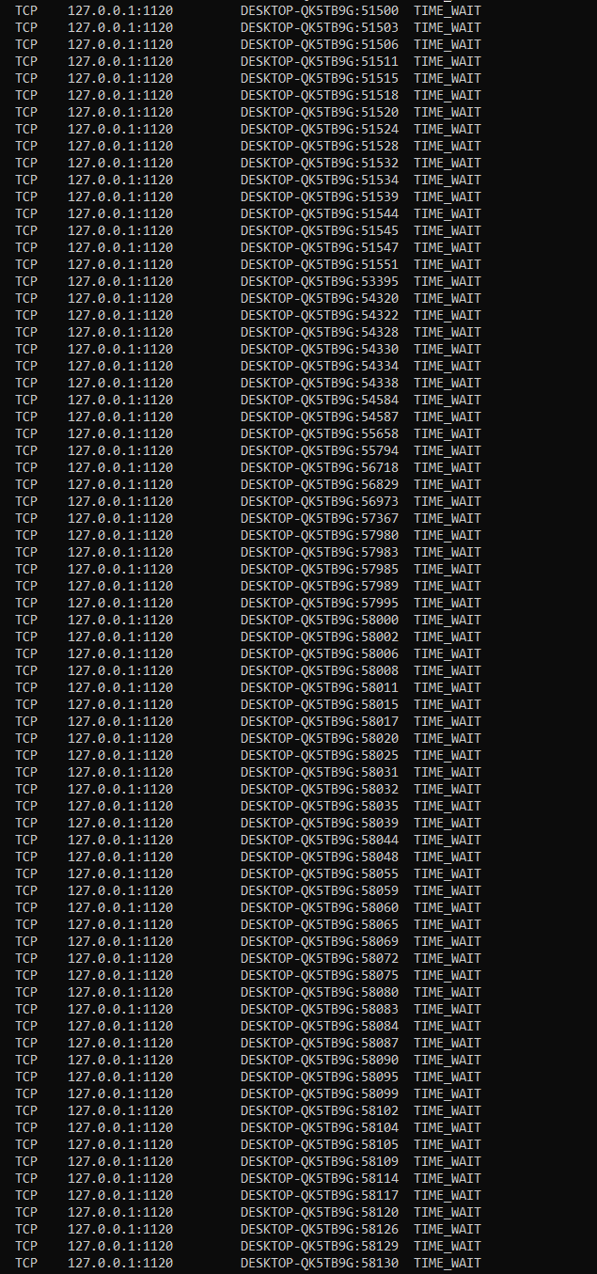

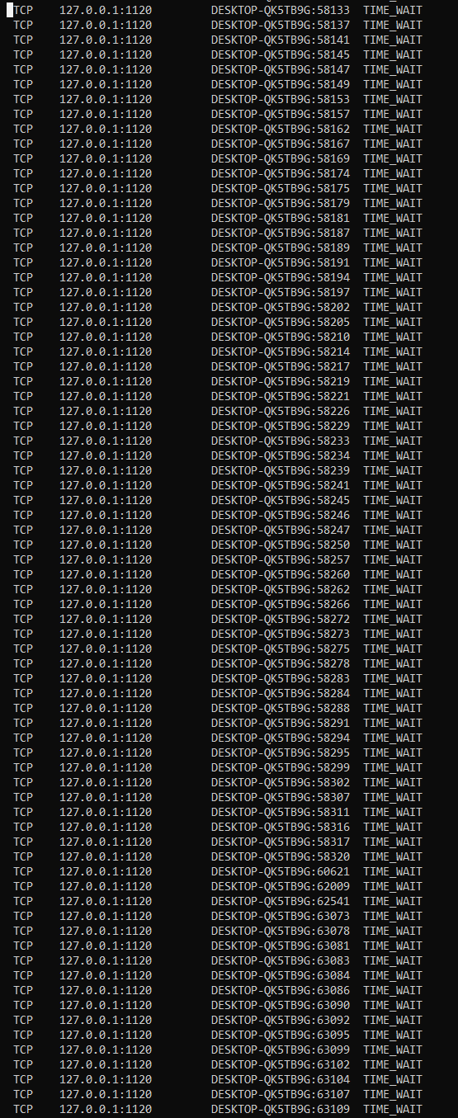

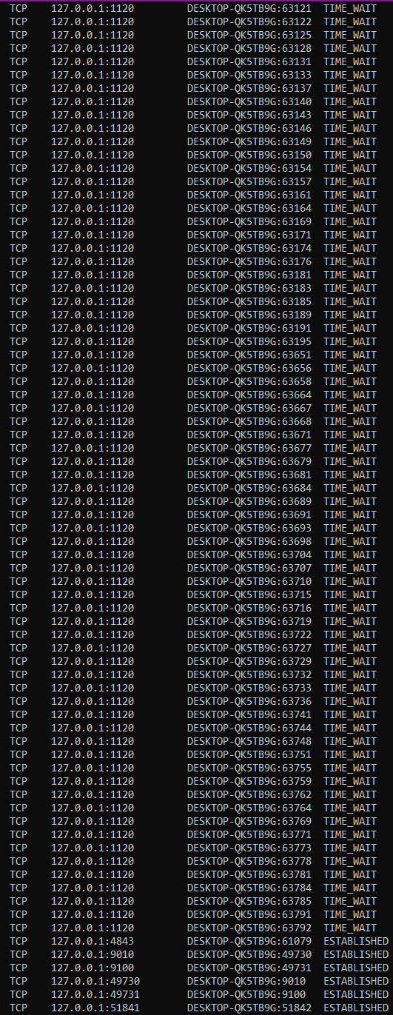

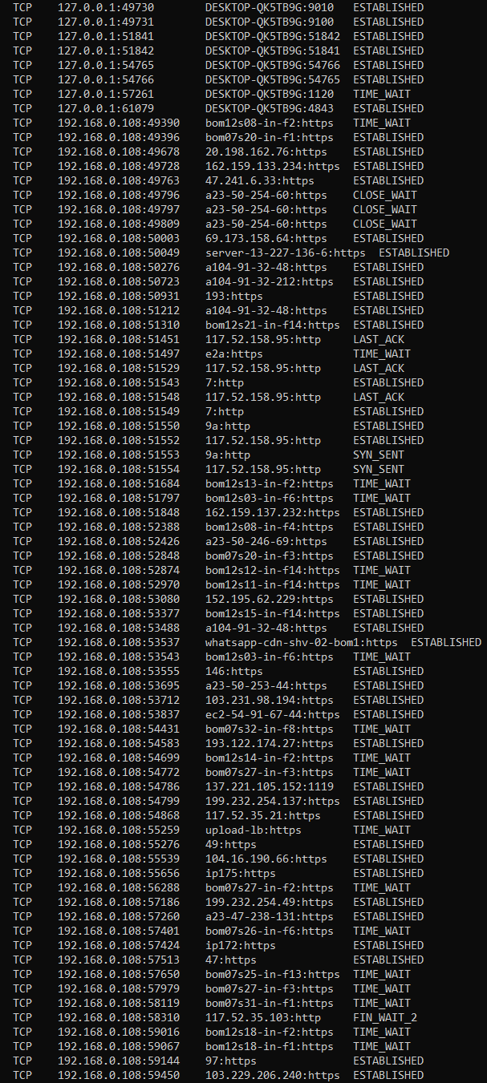

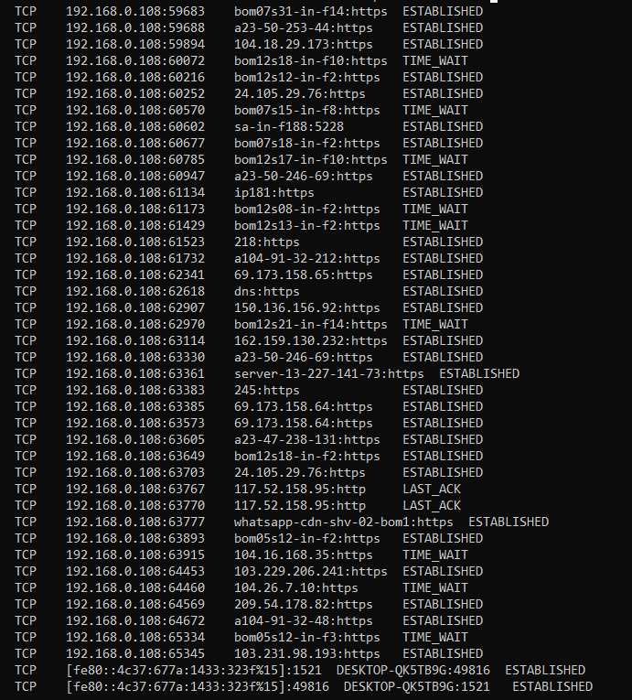

**Route:**

The **route** command allows you to make manual entries into the network routing tables. The **route** command distinguishes between routes to hosts and routes to networks by interpreting the network address of the *Destination* variable, which can be specified either by symbolic name or numeric address.

